CS540

Matthew Getter

**Instructions/Description**

**How to Install FCC Towers to Postgres and QGIS**

*Please use these instructions in conjunction with the guided video.

1. Go to my GitHub:

<https://github.com/Dancekonig/CS540-Task3.git>

Download the zip file “fcctowers.zip”, then extract into: c:\temp\cs540\gis .

1. Edit the get_load batch file in gis folder, type/copy:



1. Then run this code in CMD. (# This loads data to Postgres (pg Admin))

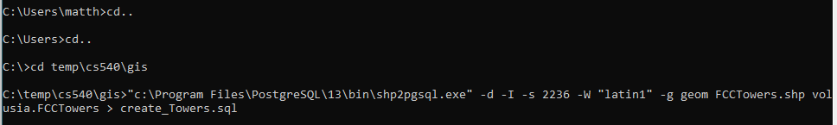



This is the attribute table in pg admin to understand the columns and values in dataset.

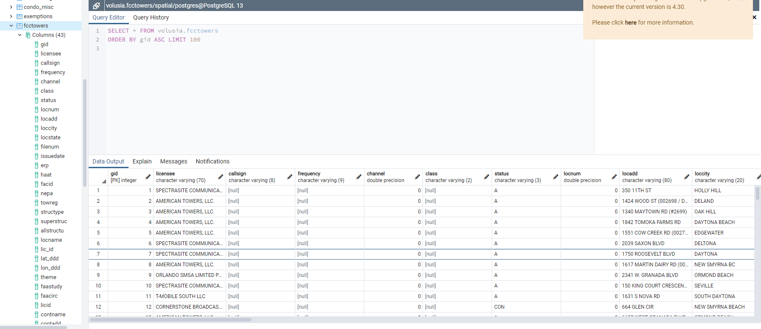

1. Open QGIS and add a PostGIS Layer with the connected “fcctowers” dataset.

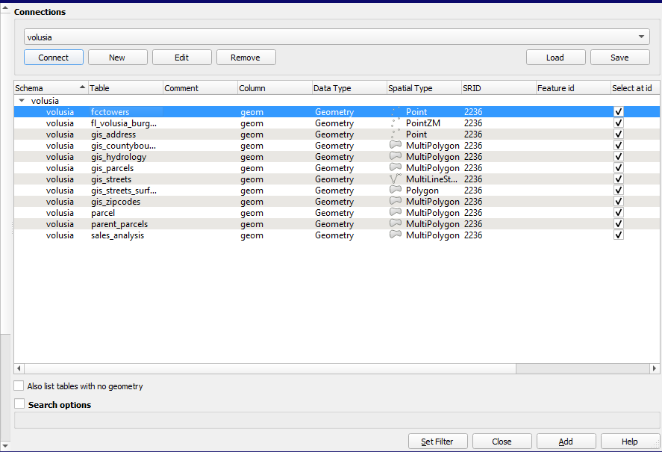

1. Once the “fcctowers” layer is added, Open DBManager and run any of the following Queries: (# This will find the 15 closest FCC Towers to the desired altkey)

Any of these quries show the same results. (# Confirmation with fcctower layer.)

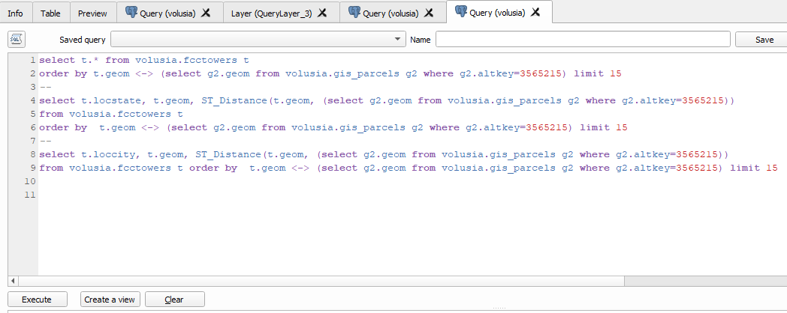

1. Attempt at finding closest parcel by a given Tower and it’s gid number:(#endless query load)

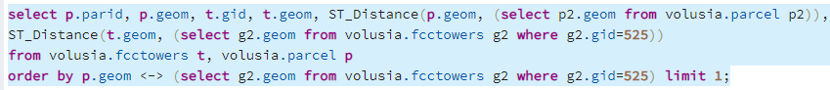

1. Add column in parcel table:



1. Update the geometry to parcel table:



1. Update towerdistance column for given parid: (#endless query loading) table didn’t update!



**Alternative:** Instead, changed towerdistance to binary: (#this shows parcels that intersect within 300M of an FCC Tower. Zoned the parcels, if they are at risk of tower proximity.



#Codes shows 2000ft= 600M, but I chose 1000ft=300Meters.

1. Add PostGIS layer for volusia.parcels: categorize for towerdistance in properties=binary map



1. Find closest parcels to a given parid that are found **only** in a red zone(#binary towerdistance):



1. **(optional)** change the properties and symbology of new Qgis Layers to get: a buffer for Cell area coverage. / Distance to a tower if a residence is too close for health reasons.

These buffers can be added in two easy ways. The third way can be done via SQL but requires definitive x, y gis points to create a single buffer.

* First way: Choose circle shape in properties and use ‘Meters at scale’. (#Double the desired distance for accuracy. E.g., For 300M area you put 600 in Size.)

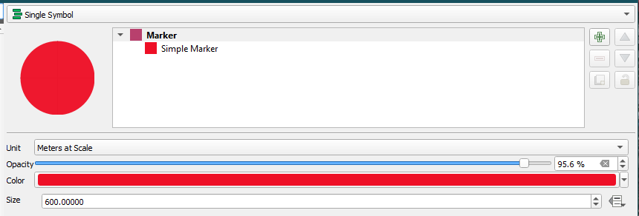

* Second Way: Vector>Geoprocessing Tools> Buffer. (# This is just a temporary layer.)

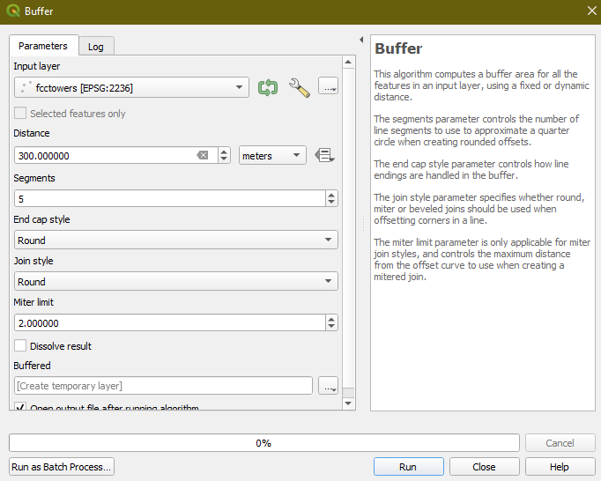

**End Results:**

The following pictures should show the same results as instructed above:

15 closest FCC towers to Embry Riddle (Altkey= 3304268):

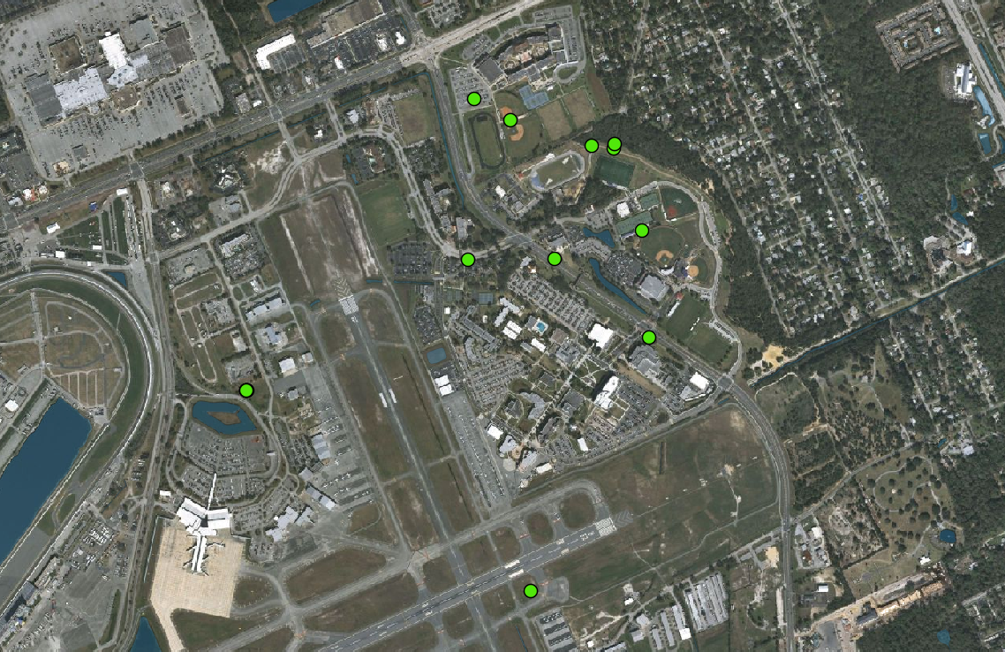

Show all Towers for confirmation (#overlap):

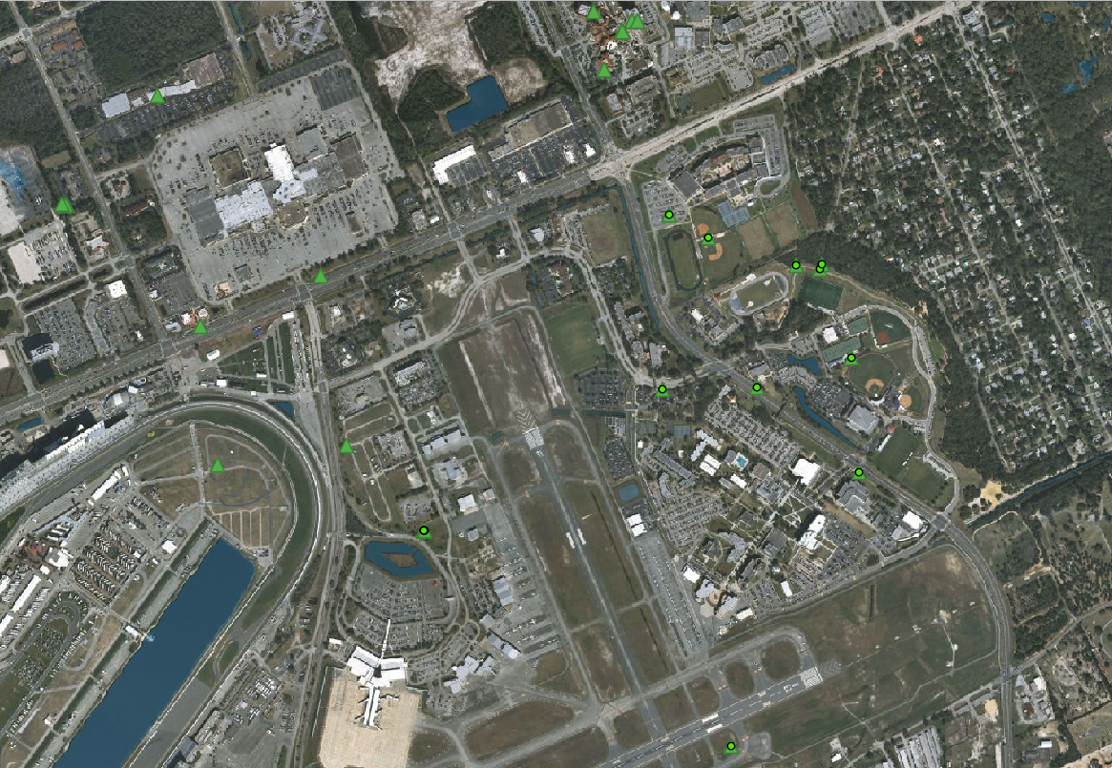

With Optional Symbology/Properties, find a buffer: Red depicting health risk @300M radius and Yellow @600M radius presenting a medium/cautionary zone for a living area.

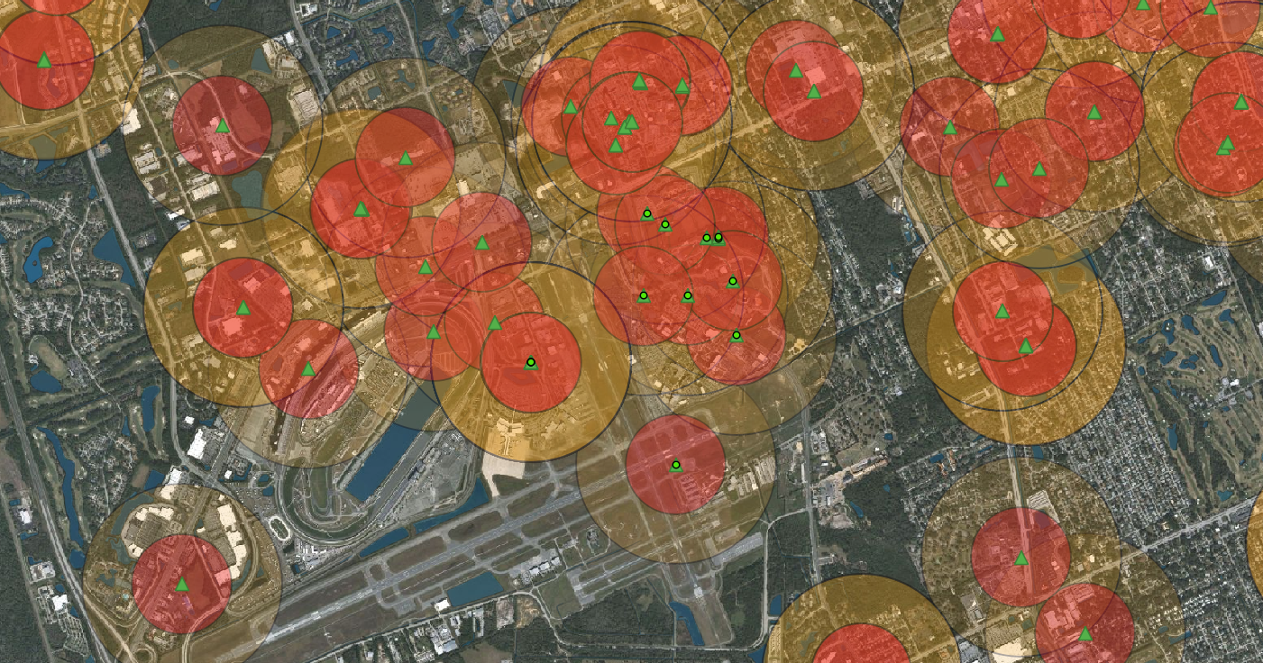

Highlighted parcel shows Embry Riddle: Relatively close to many towers and in 3 red zones.

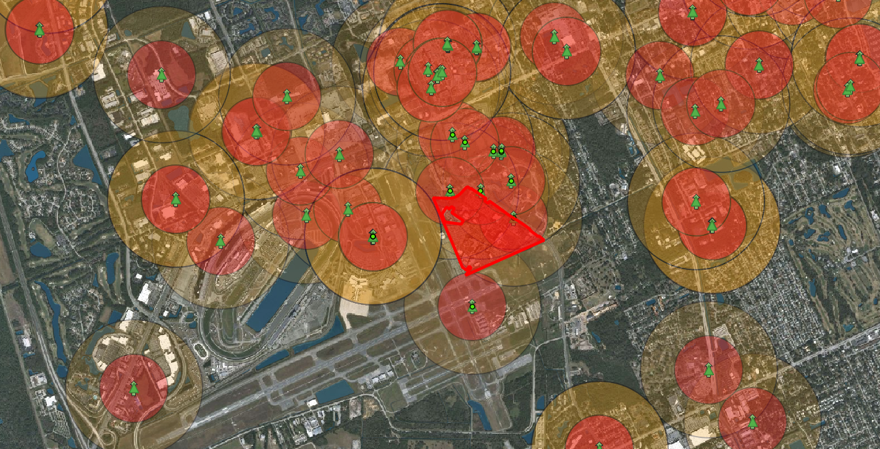

Finding Maximum Cell area/coverage in Volusia County (w/ overlap) @ 35405 Meters:

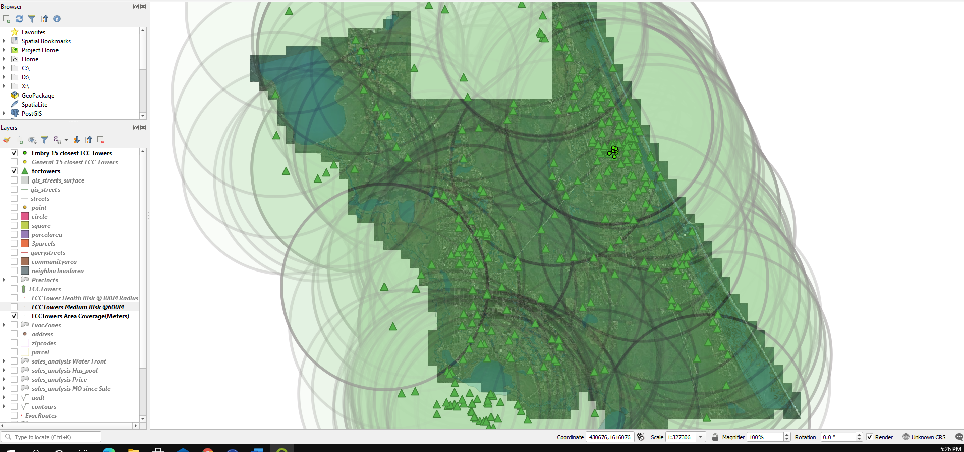

Binary Parcel/FccTower Intersection @300M: Shows towerdistance column in binary where parcels that intersect within 300M of an FCC Tower are highlighted red. This classifies the parcels in two, so you know whether a living area is at risk of tower proximity.

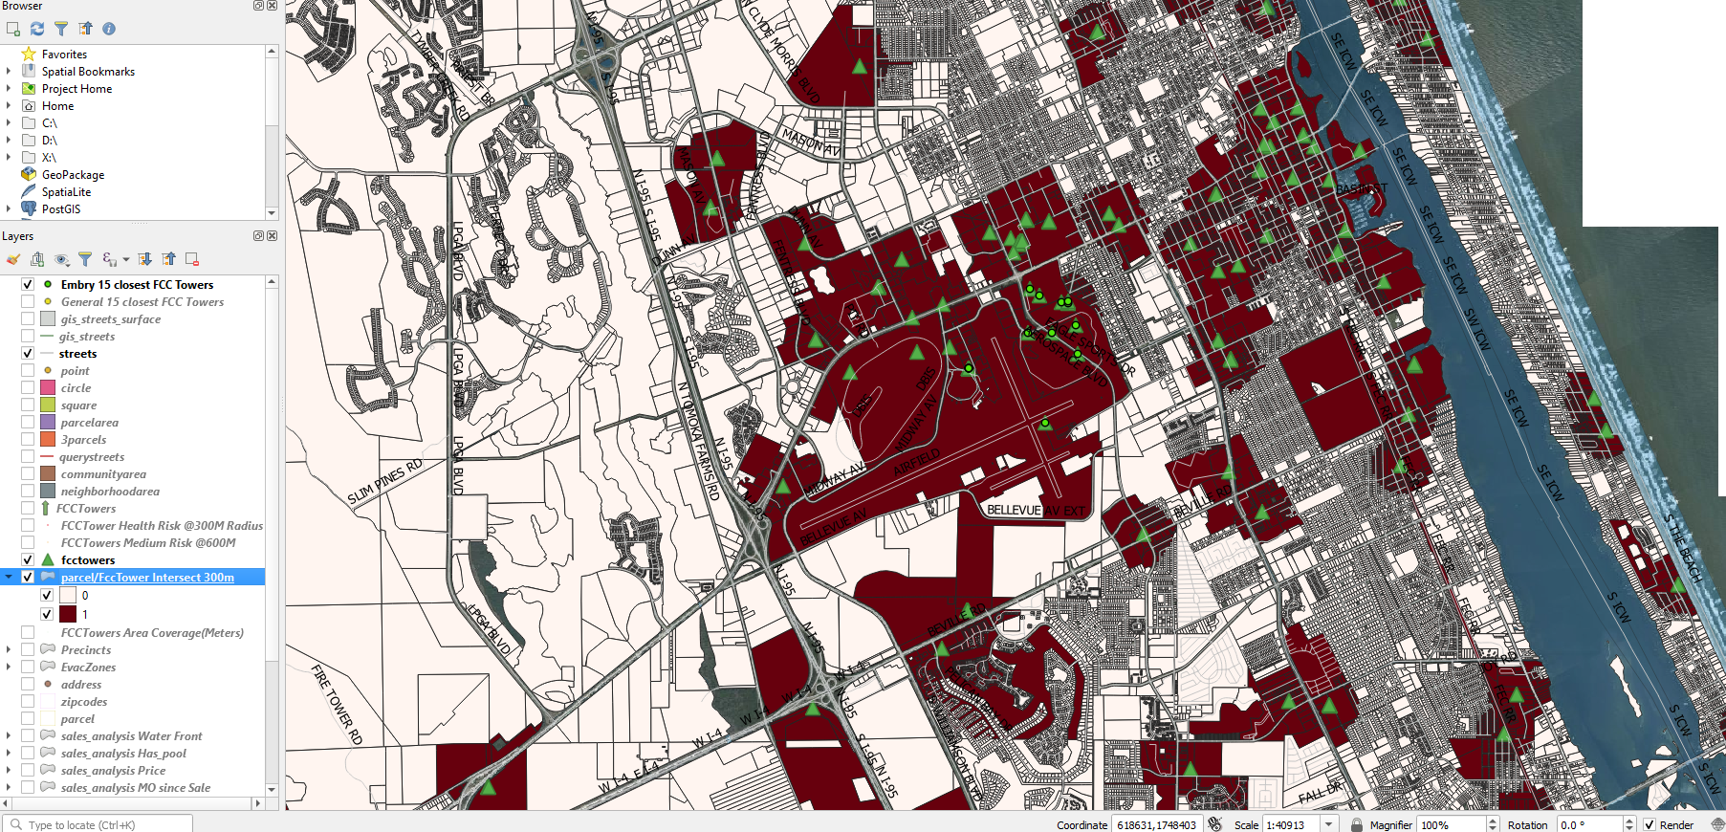

15 closest parcels in a RED zone: Finds closest parcels to a given parid that are ONLY found in a red zone (#binary towerdistance).

